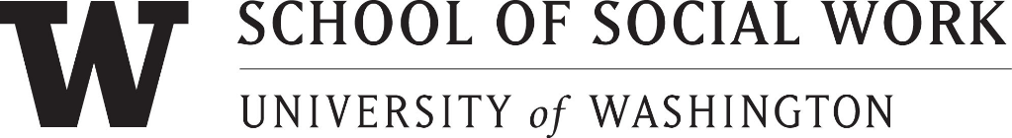

NOMINATION FORM

The Mary Grembowski Staff Recognition Award
_____________________________________________________________________

Please complete this form or include the below information with your letter of nomination:

Nominee:
Unit/Office:

Job Title/Responsibility:

Supervisor’s Name:

Others to be contacted in support of this nomination (please provide email address/contact information if individual to be contacted is outside of SSW):

Nominator’s Name:

Please check if: _____ Faculty

_____ Staff

_____ Student: Undergraduate _____
MSW Program _____
Ph.D. Program _____
Unit/Office:

Phone:

Signature of Nominator: _____
DEADLINE FOR SUBMISSION: Wednesday, May 10, 2024

FORMS AND LETTERS ARE DUE NO LATER THAN
Wednesday, May 10, 2024.

SUBMIT TO: The Mary Grembowski Staff Recognition Award Selection Committee
c/o SSW HR at sswhr@uw.edu

Presentation of the award will be made during the Faculty/Staff Spring Meeting & Recognition.

SEE ATTACHED INFORMATION

Past Recipients:
Year Recipient Dept/Area

- John Armstrong Admissions
- Olivia Zapata Deans Office
- -
- David Snyder Media Center
- Marilyn Gregory Research Project
- Cheryl Yates Practicum
- Cindy Riche Computing
- Peggy West Admin. Staff
- Davy Tep Student Services
- Kathryn Wilham Ph.D. Program
- Darian Shaw NWICF
- Juanita Ricks Admissions
- Roberta Aldrich Student Services
- Kim Dennison Deans Office
- Carrie Leath Continuing Educ.
- Linda Ruffer Student Services
- Marie Bolstad Deans Office/Reception
- Jennifer Maglalang MSW Program
- Barb Woods Deans Office
- Angela Lee Library
- Madeline Galbraith Deans Office
2014* Brooks Callison SSWIT
- Leanne Do MSW EDP
- Jennifer Kitajo Partners for Our Children
- Laura Orlando Partners for Our Children
- Desiree Schatz Deans Office
- Nancy Tran Student Services
2020 Andrea Wagner Deans Office
2021 Angela Rambo CWTAP
2022 Nicole Guenther BASW program
2023 Aliyah Vinikoor MSW Program

*Inaugural year for the Mary Grembowski Staff Recognition Award

